Our House Teams from Robin Class, Kingfisher Class and Swallow Class gathered together in the hall. Revd. Claire Robertson welcomed us and explained the order and reason for our prayer walk.
Rogation means ‘Asking’ and as we journeyed around the four stations in the village we would be asking God’s blessing and thanking Him for all the good things we have.
ROGATION PRAYER WALK - Wednesday 18th May – supported by Revd. Claire  - School  - The Pond – Village  - Church Garden  - Church Prayer Station | 2.  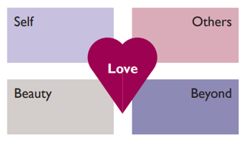  1.  4. 3.

We stared off in school with Fire Team leading us in prayer. Revd. Claire opened our prayers with the words
‘As we rejoice in the gift of this new day
So may the light of your presence, O God,
Set our hearts on fire with love for you.’
Fire Team responded:
We pray for ourselves as we begin another school day. Lord bless us (altogether)
As we learn through study and play. Lord bless us
As we meet in this hall, in our classrooms, in the library and in the playground. Lord bless us
Look after our teachers, the governors and all those who look after our school. Lord bless them
Keep us safe here in school and on our journey home. Lord bless us
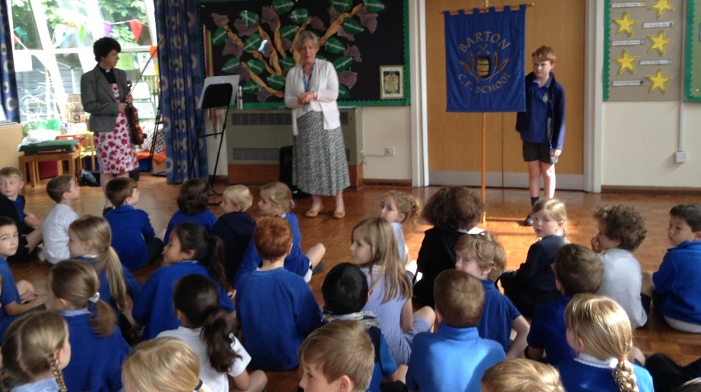

Following Arthur, who kindly carried our Barton Banner we set off into the village.
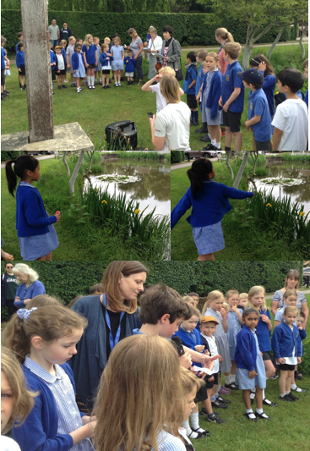
We then walked to the heart of the village to The Pond where Water House prayed God’s blessing on our community in Barton.
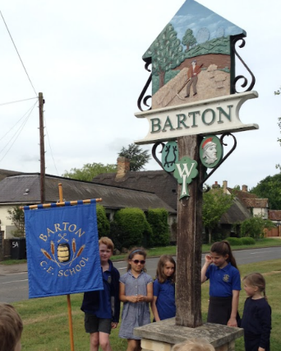
One pupil in Kingfisher Class threw a flower into the pond symbolising the impact of prayer as it ripples out into the community.
Our pupils in Water Team prayed for those who work and serve in the village, for places of Sport and recreation activities, for those who live in the village and for our Parish Council.
From the Pond we then followed on to our next Prayer Station.
We walked through the village, towards the church, arriving at a beautiful wildlife area, known to the children as The Orchard.

The whole earth is filled with awe at the wonders of your creation Lord. Where morning dawns, where evening fades you call forth songs of joy Psalm 65 vs 8.
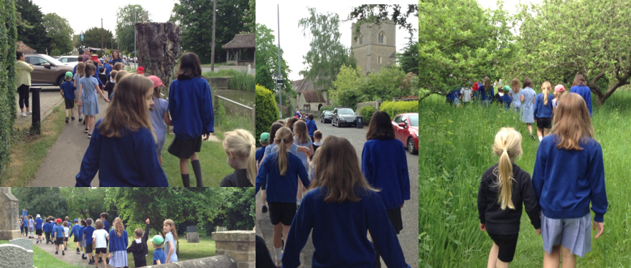
Here Earth Team asked for God’s blessing on His creation and asked that we might have His help in caring for and looking after our world.
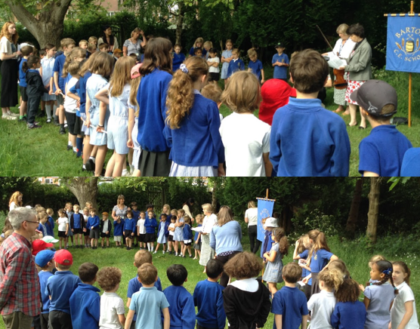
. . . and so our final prayer station led us to the church, standing in front of St. Peter’s. Attached to the tree was a heart, decorated by the pupils of Barton Church of England Primary School, in blue and yellow ribbons, the colours of the Ukranian Flag.
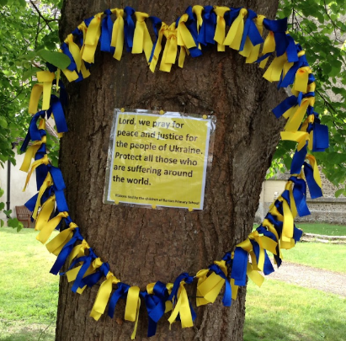

Together in the beauty of God’s creation and in the quiet stillness of the day we prayed for those suffering in Ukraine.
Lord, bring peace and justice for the people of Ukraine. Lord bless them
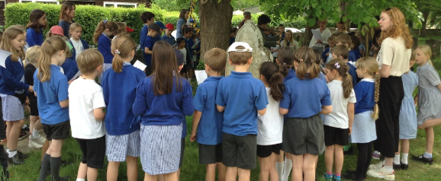
Lord as we welcome the visitors of Ukraine and all those who are far away from home. Lord bless our friendships
Lord we ask you to bless all children who live in your beautiful yet fragile world. Lord bless us all

. . . and to break the hushed silence together we sang The Lord’s Prayer and Revd. Claire played the Ukranian National Anthem on her violin . . . a very poignant moment.

