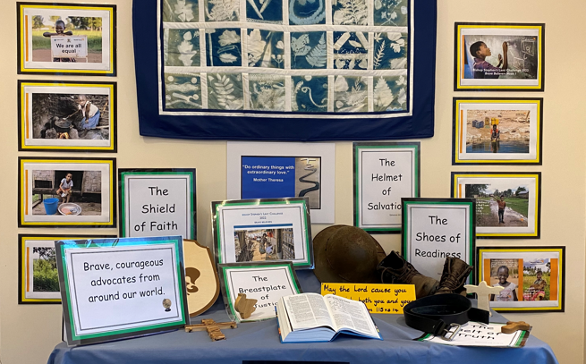

This season we will be journeying through Bishop Stephen’s Lent Challenge – Brave Believers.

