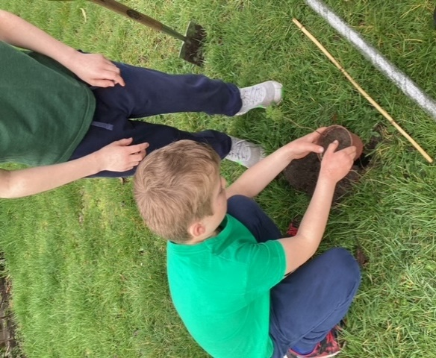
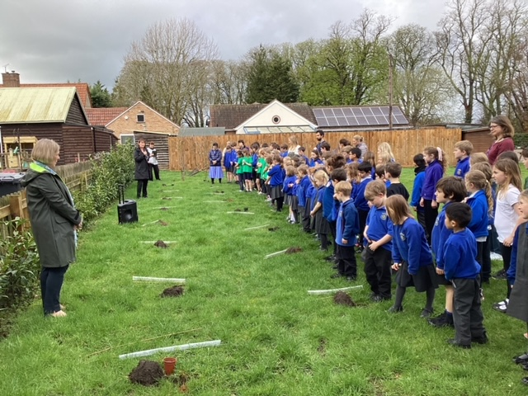
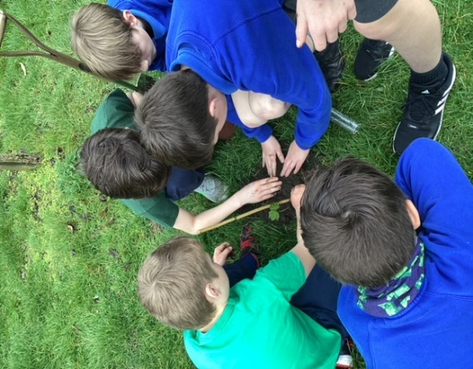
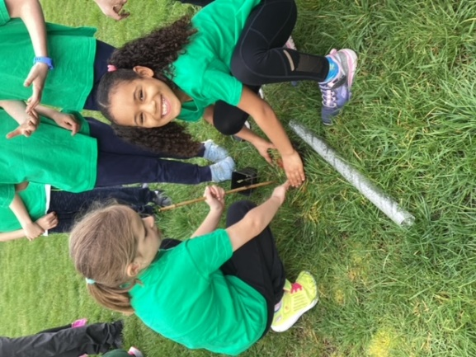
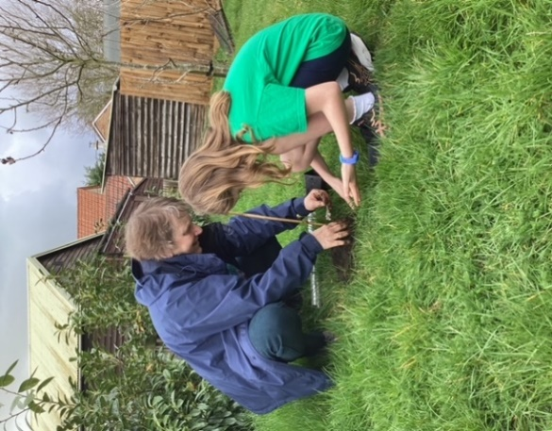
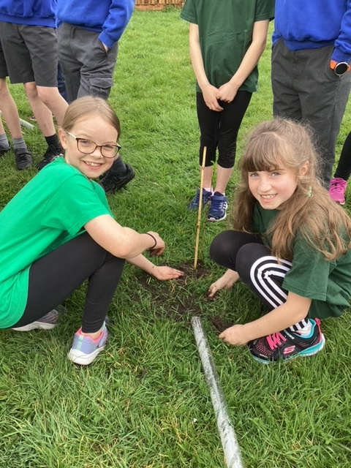
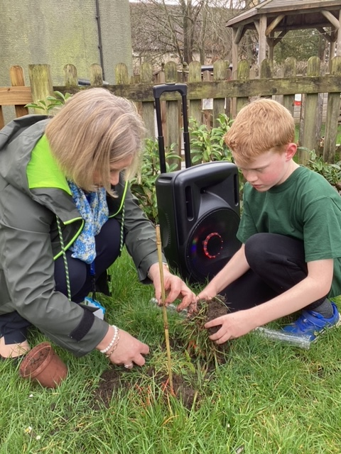
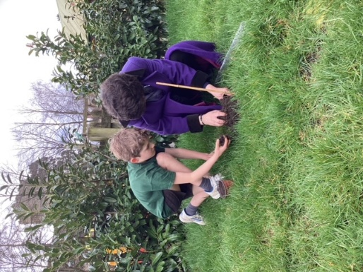
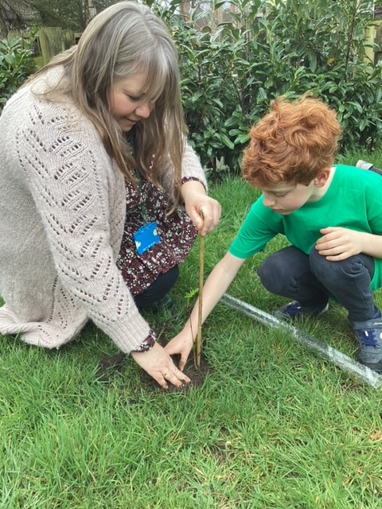

Tree planting Friday 31st March 2023
- Courageous Advocacy Project / Science Week
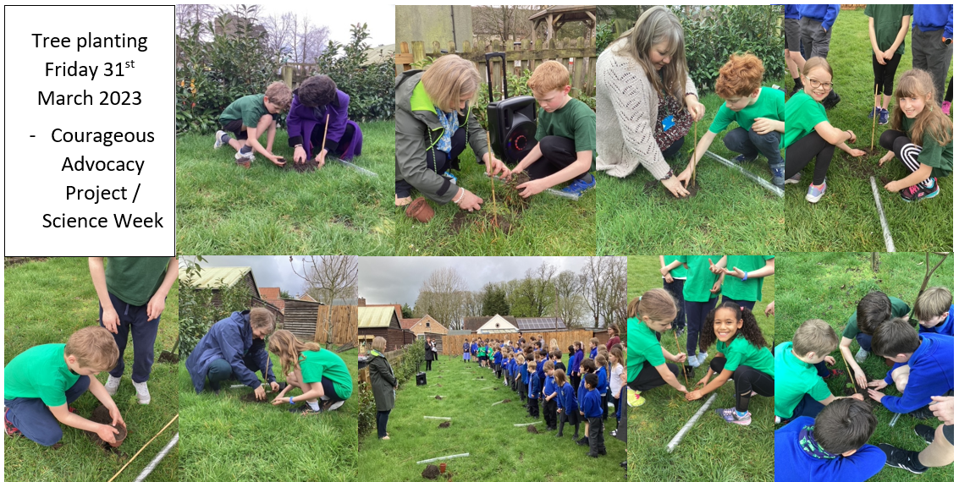

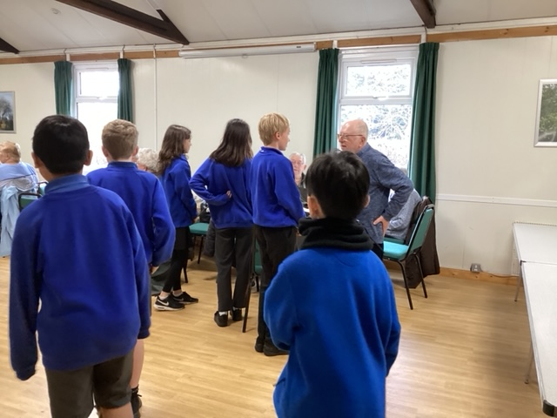
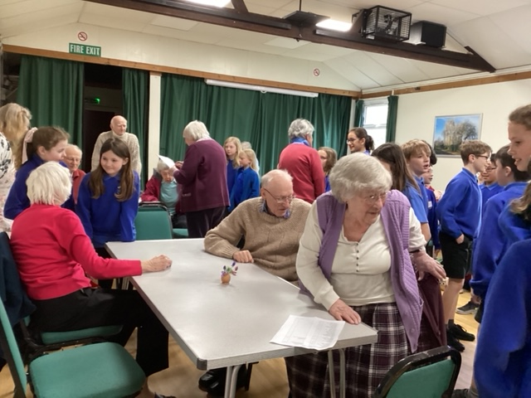

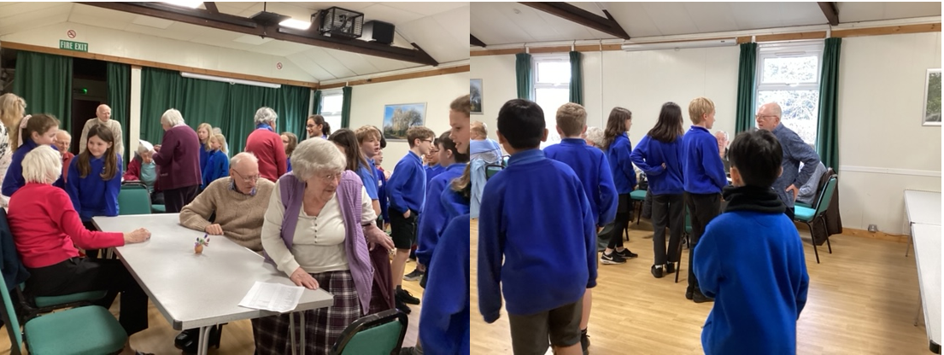
By invitation our friends from Barton Luncheon Club joined us for Collective Worship. Our Year 5 and Year 6 pupils escorted the ladies and gentlemen from the Village Hall across to school. They were also treated to a Cream Tea. It was great to see generations of friends together again. A great afternoon of song, dance and drama was enjoyed by all.

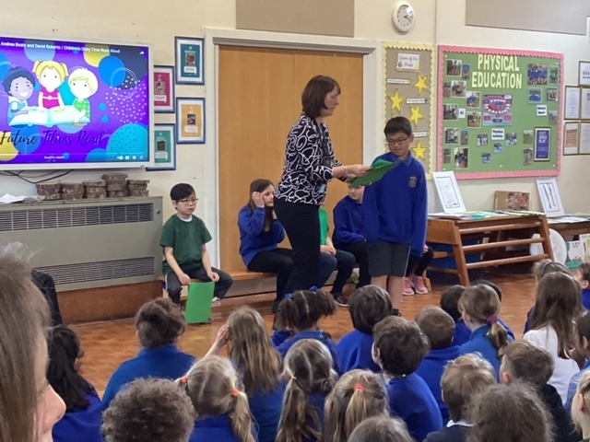
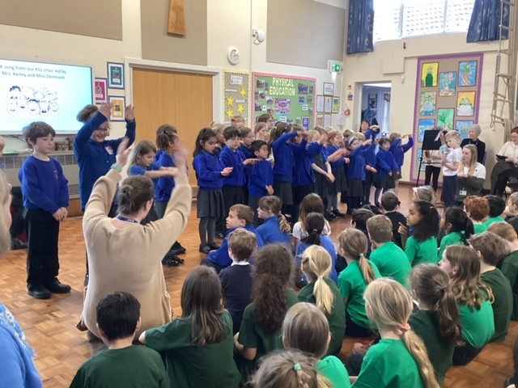
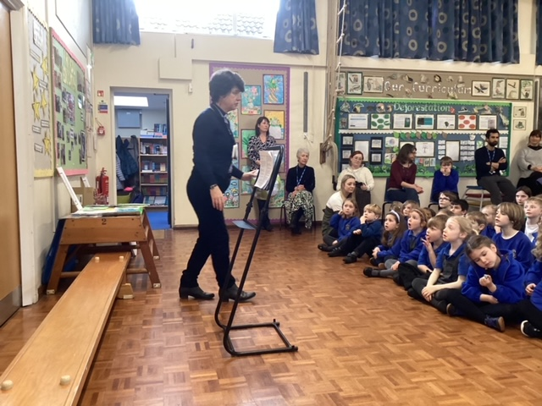
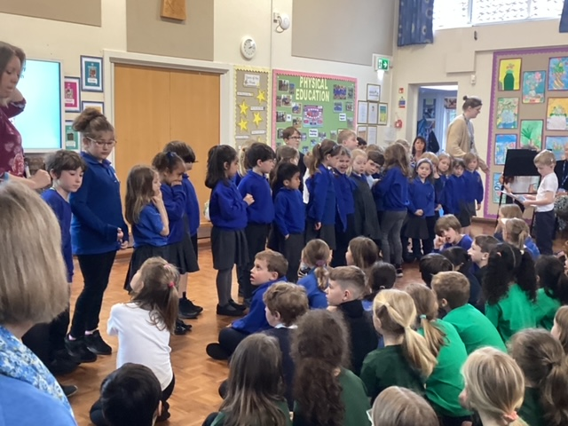
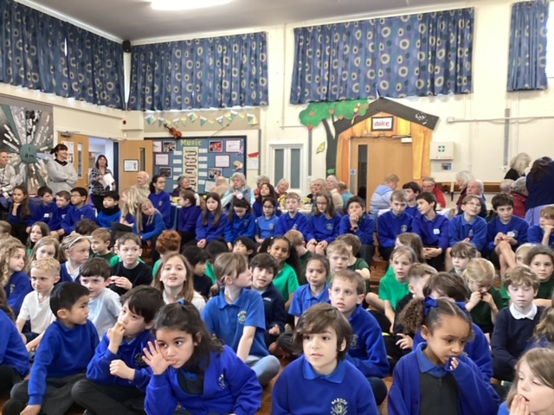
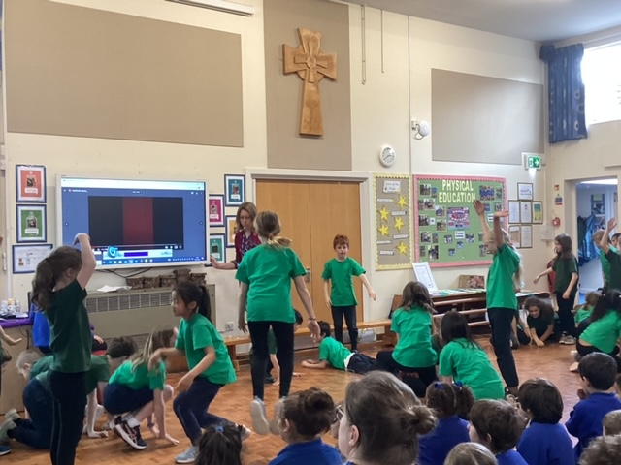
In dance and story, Swallow Class pupils and in singing our KS1 choir shared with our friends the events of the past few weeks in our preparation for this end of term celebration.

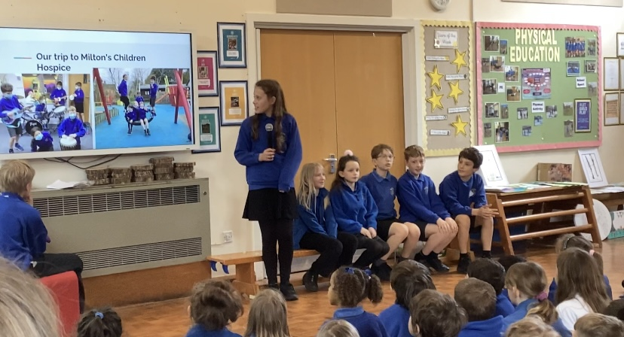

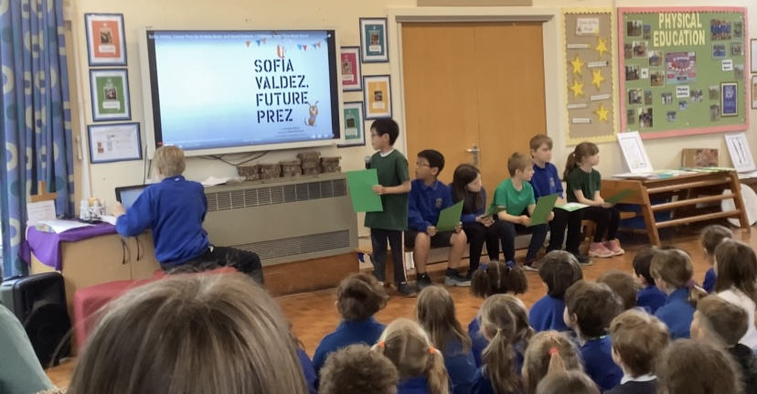

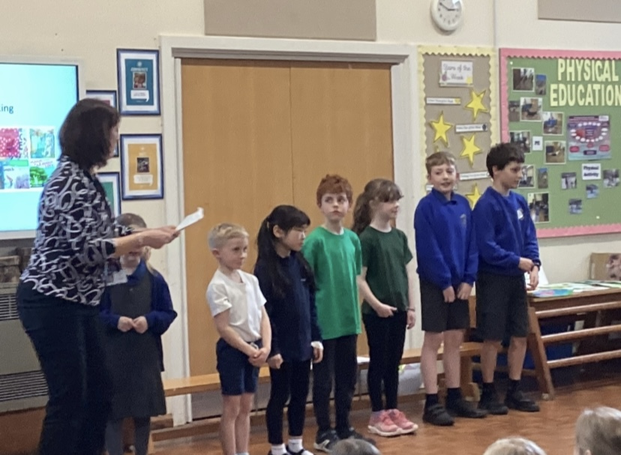
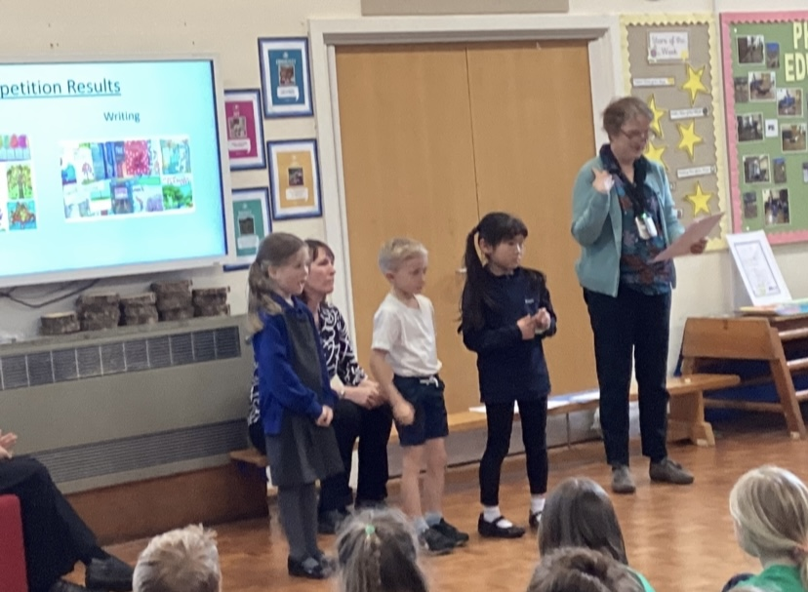

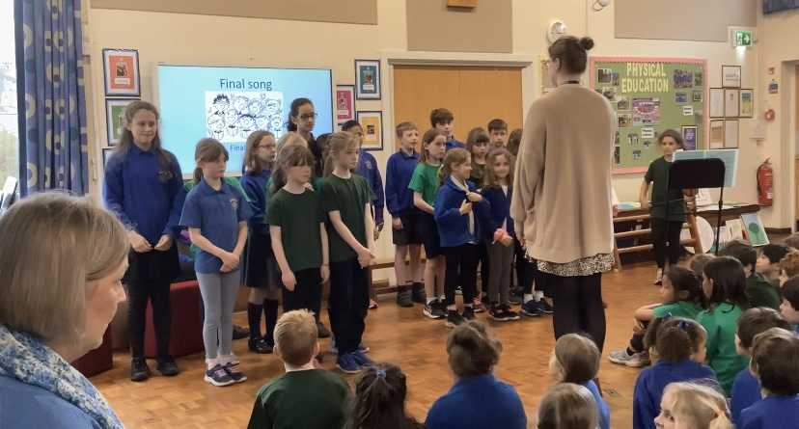
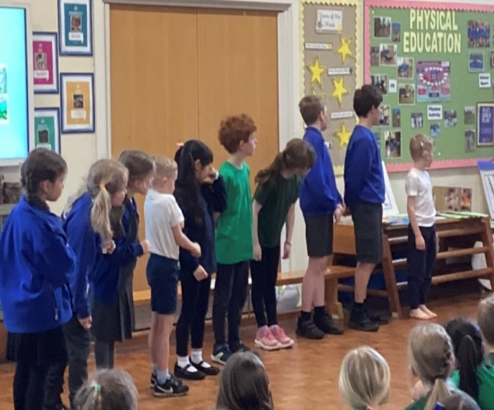

Well done to the winners of the Art and Writing competitions. A special ‘thank you’ to Pippa Goodhart, a local, well known author, who judged the writing and to Sharon Wildsmith, niece of the well-known author and artist Brian Wildsmith, who judged the art work. We were most grateful to Pippa for joining us for our Celebration Event. Finally to our KS2 choir, Mrs Kerley and Miss Dennison, thank you for your singing and songs of praise and thank you to Alice and Hugh for accompanying the singers on their violins, you were both amazing. A super afternoon of celebration, praise and worship.

